AR Based Indoor Navigation Application

Final Year Project

Session 2019-2023

A 4th Year Student

A project submitted in partial fulfilment of

The University of Faisalabad Degree

of

BS in BSc. (Hons.)Software Engineering



Department of Computer Science

The University of Faisalabad, Amin Campus

22 June 2023

# Project Detail

|  |  |  |  |  |  |
| --- | --- | --- | --- | --- | --- |
| Type (Nature of project) | | | **R**esearch and **D**evelopment | | |
| Area of specialization | | | Augmented Reality and Indoor Navigation Technology | | |
| **Project Group Members** | | | | | |
| Sr.# | Reg. # | Student Name | | Email ID | *Signature |
| (i) | Bsse-fa19-007 | Umar Habib | | umarworkofficial@gmail.com |  |
| (ii) | Bsse-fa19-016 | Muhammad Hassan | | muhammadhassan2824@gmail.com |  |
| (iii) | Bsse-fa19-041 | Waleed | | waleedworkofficial@gmail.com |  |

*The candidates confirm that the work submitted is their own and appropriate credit has been given where reference has been made to work of others

# Plagiarism Free Certificate

This is to certify that, I am ________________________ S/D/o _______________________, group leader of FYP under registration no _________________ at Computer Science Department, The University of Faisalabad. I declare that my FYP proposal is checked by my supervisor and the similarity index is ________% that is less than 20%, an acceptable limit by HEC. Report is attached herewith as Appendix A.

Date: ____________ Name of Group Leader: ________________________ Signature: _____________

Name of Supervisor: _____________________ Co-Supervisor (if any):____________________

Designation: _____________________ Designation: _____________________

Signature: _____________________ Signature: _____________________

HoD: _____________________

Signature: _____________________

**CERTIFICATE**

We accept the work contained in the report titled “**AR-Based Indoor Navigation Application**”, written by “**Waleed, Umar and Hassan**” as a confirmation to the required standard for the partial fulfilment of the degree of Bachelor of Science in Software Science.

**Approved by:**

**Supervisor:** Dr. Majid Hussain

**Signature:**

**Internal Examiner:**

**Signature:**

**External Examiner**:

**Signature:**

**FYP Coordinator**: Muhammad Rehman Shahid

**Signature:**

**Head of the Department**: Dr. Majid Hussain

**Signature:**

**Date: 22/06/2023**

**Abstract**

This project addresses the challenges in navigating inside large and complex buildings faced by an individual unfamiliar with the building infrastructure and the insufficiency of traditional navigation tools in indoor spaces by developing an Augmented Reality (AR) based Indoor Navigation Application. The project focuses on creating digital maps of indoor spaces using manual mapping techniques and implementing location tracking using SLAM (Simultaneous Localization and Mapping) algorithm and QR code technology for user's current location. By utilizing the AR Core library, the application overlays digital objects onto the real-world environment, providing users with an intuitive and immersive navigation experience. Pathfinding is achieved through the NavMesh tool in Unity, which calculates the shortest path to the desired destination. Unlike other existing technologies the proposed system eliminates the need for external hardware used for mapping and localization. This approach not only saves time, energy, and cost but also offers accurate indoor navigation without the dependence on external devices.

**Acknowledgement**

First of all, we are grateful to Allah Almighty the most Merciful, the All-knowing, for his blessings, guidance and the courage bestowed upon us throughout the completion of our project. We would also like to show our gratitude to our supervisor, Dr. Majid Hussain for giving us valuable advice, support and expertise throughout the project. Furthermore, we would like to express our heartfelt gratitude to our families for their unconditional love, encouragement, and patience throughout this journey. Their constant support and prayers have been a significant factor in the successful completion of this project. Additionally, we would like to express our gratitude to our fellow classmates and friends who have provided us with valuable insights, feedback, and moral support throughout this project. Lastly, we acknowledge the collective efforts of all those who have contributed, however big or small, in the successful completion of this project. May Allah Almighty bless everyone involved and guide us in our future projects (Ameen).

**Table of Contents**

1 Introduction 5

1.1 Background 5

1.1.1 Infrared Signals Navigation Approach 5

1.1.2 Wi-Fi-Based Localization Approach 6

1.1.3 Bluetooth Beacons-Based Localization Approach 6

1.1.4 Marker-Based Localization Approach 6

1.1.5 Vision-Based Localization Approach 6

1.1.6 Pedestrian Dead Reckoning Localization Approach 6

1.2 Project Vision 7

1.3 Problem Statement 7

1.4 Objectives 7

1.5 Project Scope 7

1.5.1 Market Competitors 7

1.5.2 Business significance 7

1.5.3 Business Plan 8

1.5.4 Constraints 8

2 Requirement Analysis 9

2.1 Literature Review / Existing System Study 9

2.1.1 Title: Indoor Navigation Using Augmented Reality 9

2.1.2 Title: Indoor Navigation with Augmented Reality 9

2.1.3 Title: Indoor Navigation Using Augmented Reality 10

2.1.4 Title: SLAM-based Indoor Navigation in University Buildings 10

2.2 Stakeholders list 11

2.3 Requirement Elicitation 11

2.3.1 Functional Requirement 11

2.3.2 Non-Functional Requirements 12

2.3.3 Requirements Traceability Matric 13

2.4 Software development life cycle model 13

3 System Design 14

3.1 Use Case Diagram 14

3.2 Activity Diagram 15

3.3 Domain Model Diagram 16

3.4 System Sequence Diagram 17

3.5 Sequence Diagrams 18

3.6 Class Diagram 19

3.7 Architecture Diagram 20

3.8 Work breakdown structure (WBS) 21

3.9 Collaboration Diagram 22

3.10 Gantt chart 23

4 System Testing 24

4.1 Test Cases 24

5 Conclusion 30

5.1 Problem faced and lessons learned 30

5.2 Project summary 30

5.3 Future work 30

6 References 31

Appendix A: User Interface 32

Appendix B: Plagiarism Report 34

**List of Tables**

Table 2.1: Functional Requirements of AR-Based Indoor Navigation App 12

Table 2.2: Non-Functional Requirements of AR-Based Indoor Navigation App 12

Table 2.3: Requirement Traceability Matric of AR-Based Indoor Navigation App 13

Table 4.1: Test Case 1 (Pass) of AR-Based Indoor Navigation App..............................................24

Table 4.2: Test Case 1 (Fail) of AR-Based Indoor Navigation App 25

Table 4.3: Test Case 2 (Pass) of AR-Based Indoor Navigation App 26

Table 4.4: Test Case 2 (Fail) of AR-Based Indoor Navigation App 27

Table 4.5: Test Case 3 (Pass) of AR-Based Indoor Navigation App 28

Table 4.6: Test Case 3 (Fail) of AR-Based Indoor Navigation App 29

**List of Figures**

Figure 3.1: Use-Case Diagram of AR-Based Indoor Navigation App 14

Figure 3.2: Activity Diagram of AR-Based Indoor Navigation App 15

Figure 3.3: Domain Model Diagram of AR-Based Indoor Navigation App 16

Figure 3.4: System Sequence Diagram of AR-Based Indoor Navigation App 17

Figure 3.5: Sequence Diagram of AR-Based Indoor Navigation App 18

Figure 3.6: Class Diagram of AR-Based Indoor Navigation App 19

Figure 3.7: Architecture Diagram of AR-Based Indoor Navigation App 20

Figure 3.8: WBS of AR-Based Indoor Navigation App 21

Figure 3.9: Collaboration Diagram of Indoor Navigation App 22

Figure 3.10: Gantt chart of AR-Based Indoor Navigation App 23

# Introduction

The term ‘navigation’ collectively represent tasks that include tracking the user’s position, planning feasible routes and guiding the user through the routes to reach the desired destination. Location-based services such as indoor and outdoor navigation are really helpful. Outdoor navigation is used to navigate outside the buildings with the help of The Global Positioning System (GPS) and Indoor navigation is used to navigate inside a building with different technologies without using GPS because in Indoor environments, the GPS cannot provide fair accuracy in tracking.

The Indoor Navigation System uses different Indoor Positioning System (IPS) technologies that tell the current location of the user and guides the user to the desired destination through a path integrated with augmented reality arrows. Augmented Reality (AR) is the technology that lay over digital objects into real-world view environment. It also enhances the user experience.

Many people are confused between the terms AR and VR. The AR refers to Augmented Reality that adds computer generated images or digital objects into the real-world view environment. This makes the navigation feel more interactive and immersive. While VR refers to the Virtual Reality that replaces the real-world environment by placing the user in artificially generated environment.

## Background

For Outdoor Navigation System GPS is enough for navigating the user with high accuracy but for Indoor Navigation System the GPS does not provide accuracy due to infrastructural barriers, signal attenuation etc. So, different approaches were introduced although they do not provide high accuracy as GPS but play an important role in Indoor Navigation. Different approaches for **Indoor Navigation and localization** are as follows:

### 1.1.1 Infrared Signals Navigation Approach

Infrared Signals navigation utilizes invisible light signals to determine location and provide navigation guidance within an indoor environment. In this technique we use infrared beacons or transmitters and place them throughout the area of interest.

The infrared beacons emit unique infrared signals with specific patterns or codes. These signals are detected and interpreted by specialized receivers or devices equipped with infrared sensors. By analysing the strength, direction, and timing of the received signals, the device can calculate the user's position and orientation relative to the beacons.

### Wi-Fi-Based Localization Approach

Wi-Fi is a commonly used technology for determining the position of mobile devices inside buildings. In this technology, there are Wi-Fi access points installed throughout the building. These access points emit signals that mobile devices can detect when they come within range. When a user enters the range of Wi-Fi access points with their mobile device, the device detects and receives these signals. The system analyses the signals received from multiple access points to determine the user's position.

### Bluetooth Beacons-Based Localization Approach

In this technology, small devices called Bluetooth beacons are placed at known fixed positions inside a building. These beacons emit Bluetooth signals. The mobile device acts as a receiver and detects the signals being emitted when comes within the range of these Bluetooth beacons, by analysing the signals received from multiple beacons, the device can determine its relative position in relation to the known beacon locations.

### Marker-Based Localization Approach

It involves scanning an image that contains a specific marker. Once the marker is scanned, it is extracted, revealing a unique Marker-ID that is stored in a database. This database holds corresponding location or position information associated with the Marker-ID, enabling accurate localization.

### Vision-Based Localization Approach

It involves extracting visual features from the surroundings, such as landmarks or objects, and matching them with a pre-existing map or reference images. By analysing these visual cues, vision-based localization provides estimation of user’s position.

### Pedestrian Dead Reckoning Localization Approach

Pedestrian Dead Reckoning (PDR) Localization technique uses motion sensors, such as accelerometers and gyroscopes, to track a user's position by counting the steps. It measuring changes in velocity, acceleration, and orientation to estimates the user's movement and updates the position accordingly.

## Project Vision

Our vision is to create an immersive and enjoyable navigation experience that eliminates the use of traditional maps. With our Augmented Reality-Based solution, we aim to provide a user-friendly interface that eliminates confusion, provide the users hassle-free navigation, saving both their time and energy.

## Problem Statement

Traditional navigation tools such as maps and signs are tiring, unattractive and are not sufficient enough in guiding the user efficiently.

## Objectives

**Enhance Indoor Navigation:** Provide users with a user-friendly and intuitive platform to provide easy and hassle-free navigation.

**Enhance User Experience:** Provide accurate and real-time navigation guidance to users within indoor environments.

**Save Time and Energy:** Enable users to reach their destination quickly and efficiently by providing optimized routes.

## Project Scope

This application provides navigation to the user who is unfamiliar with the large and complex building structure with the assistance of augmented reality. Buildings can be hospital, super mart, university, airport, railway station etc. This application localizes the user, takes it current location and guide the user to the destination through line rendering arrows. This application not only saves time but a lot of energy as well.

### Market Competitors

ARway, Mapbox, Mappedin, Pointr.

### Business significance

This application can also be used in malls, retail stores, libraries etc. in which products could be added and user can easily locate specific product which will be the cause of increase in sales and business.

### Business Plan

Our AR based indoor navigation app offers many subscription packages to meet the changing needs of our users. Basic membership is offered as a monthly or annual subscription and includes services such as indoor navigation, real-time guiding, and destination search. It is designed for small businesses or those who require basic navigation functionality. The premium subscription includes advanced capabilities such as 3D floor mapping, custom branding, user data insights and analytics. It is intended for large organizations such as shopping malls, airports and institutions that require comprehensive indoor navigation. Moreover, we provide add-on services can be provided which allow clients to add new features to their subscriptions according to their requirement such as indoor location monitoring for asset management, connectivity with external databases or APIs, and specialized modules for specific industries. To further enhance the customer experience, optional support and maintenance packages are also offered that include priority support, bug fixes, regular updates, and access to new features.

### Constraints

* Sufficient lighting conditions are required for accurate QR code scanning.
* A stable environment is required for successful scans.
* Movements or vibrations during scanning can result in inaccurate or failed scans.

# Requirement Analysis

Requirement Analysis involves identifying, documenting, and analysing the requirements of the project. It includes the following: Functional and Non-Functional requirements, Requirements Traceability Matric, Literature review or existing system study, Stakeholders, SDLC, etc.

## Literature Review / Existing System Study

This section aims to provide an overview of the existing knowledge, technologies, and approaches that are relevant to the project.

### Title: Indoor Navigation Using Augmented Reality

This paper discusses about Location-Based Services and the need for Indoor Navigation in complex buildings structure. It also highlights the issues in navigating inside the complex buildings structures faced by people of different age groups especially children and the old ones that have not much energy to be wasted in asking people directions. It states that Indoor Navigation is important not only for sighted individuals but also for those with impairments. It gives a general idea how an Indoor Navigation works, which means it localizes (taking current position) the user and guides the user to its desired destination with the help of Augmented Reality arrows. It also tells about different localization techniques, path finding algorithms, their advantages and limitations as well. Different localization techniques includes**: Marker-Based Localization, Vision-Based Localization,** and **Pedestrian Dead Reckoning Localization**. (Bacchewar *et al.*, 2022)

### Title: Indoor Navigation with Augmented Reality

This paper serves as a survey of Augmented Reality (AR) interfaces, types of AR and indoor positioning/navigation techniques. It includes old and latest technologies for implementation of Indoor Navigation. Among these navigation techniques, **Wi-Fi fingerprinting** and **RFID** require external hardware such as Wi-Fi access points or beacons. **Vision-based navigation** and **Visual Positioning System (VPS)**, on the other hand, can be implemented without relying on external hardware, although combining them can enhance computer vision accuracy. The study also explores different **types of AR** such as **Marker-Based AR, Marker less AR, Projection-Based AR,** and **Superimposition AR.** This paper states that Marker-based AR is easier to implement, but it is limited to areas with available markers while Marker less AR is more difficult to implement has great flexibility for navigation. Overall, Indoor navigation using smartphones is possible and will become even easier in the future with better technology and when integrated with Augmented Reality, it has a great potential.(Joshi *et al.*, 2020)

### Title: Indoor Navigation Using Augmented Reality

This paper focuses on the development of an **Augmented Reality-Based Indoor Navigation** system that assists users and utilizes a **cloud platform** for administrators to modify and manage the navigation paths. This AR-based mobile app is developed using the **Unity3D** framework. Furthermore, it also highlights the **two major reasons** for theNeed of an Indoor Navigation System and Integration of Augmented Reality:

* Lack of signal strength of Global Positioning System in an Indoor environment.
* Augmented Reality provides an engaging and attractive interface as compared to traditional 2D maps or navigation sign boards that are unattractive.

Apart from major reasons, there are also several challenges encountered when navigating in indoor environment, such as obstacles caused by numerous physical objects, poor lighting conditions, and signal attenuation etc. This paper also emphasizes on the importance and potential of Augmented Reality by stating that AR not only provides users with location information but also offers additional relevant details about their surroundings. It also talk about different localization techniques such as: **Infrared Indoor positioning system**, **Wi-Fi Indoor Positioning technique**, **Bluetooth Beacons** and **Augmented Reality Integrated with Different Technologies.**( Kushal Agrawal, 2020)

### Title: SLAM-based Indoor Navigation in University Buildings

This paper addresses the **limitations of GPS** in an indoor environments and discusses various scenarios that highlights the challenges individuals encounter while navigating within a large and complex buildings. This paper also discusses various projects that have implemented indoor navigation systems using different technologies. It highlights that **Bluetooth Beacon** and **Wi-Fi- fingerprinting technologies**, commonly used for indoor navigation, require additional hardware and can be expensive. As an alternative, the paper introduces **SLAM (Simultaneous Localization and Mapping)**, a technology that doesn't rely on external hardware. SLAM uses the device's camera, gyroscope, and accelerometer to provide real-time localization of the user. **Google's ARCore** and **Apple's ARKit** provide SLAM algorithms for creating augmented reality applications and indoor navigation systems. This paper also provides examples of an indoor positioning system implementation using SLAM. These examples illustrate the utilization of ARCore, Unity, SLAM algorithms, QR codes, 3D modeling, NavMesh, and optical recognition to develop indoor navigation systems with augmented reality.(Sukhareva, Tomchinskaya and Serov, 2021)

## Stakeholders list

* **Users:** The individuals who use the application.
* **Developers:** The team responsible for designing, developing, and maintaining the AR application.
* **Facility Owners/Managers:** The owners or managers of the indoor spaces where the AR navigation application is implemented.
* **IT Department:** The internal IT department of the facility or organization that oversees the technical aspects of the AR application.
* **Hardware Manufacturers:** Manufacturers of smartphones, tablets, or wearable devices that support the AR application.

## Requirement Elicitation

It is the process of identifying, gathering, and documenting the needs and expectations of stakeholders for a specific software project.

### Functional Requirement

The functional requirements are those requirements which tells the activities of the system. It tells “what the system will do”. Basically it revolves around the performance of the application. Functional Requirements of application are shown in ***Table 2.1***

Table 2.: Functional Requirements of AR-Based Indoor Navigation App

|  |  |  |
| --- | --- | --- |
| **FR 01** | **Camera** | The camera will be opened when the user opens the application. |
| **FR 02** | **QR Scan** | The user will scan a QR code after entering the building. |
| **FR 03** | **Detect Position** | The application will be able to detect the current location of the user inside the building. |
| **FR 04** | **Route Guidance** | The app will notify the user of upcoming turns through hallways, doors, and to the end destination. |

### Non-Functional Requirements

Non-Functional Requirements are the constraints or the requirements imposed on the system. Non-functional requirements of application are shown in ***Table 2.2***

Table 2.: Non-Functional Requirements of AR-Based Indoor Navigation App

|  |  |  |
| --- | --- | --- |
| **NFR 01** | **Performance** | The application must perform in proper time that cover walking speed, motion and obstacles in the environment. |
| **NFR 02** | **Security** | The data of the user would not be harmed while using thus app. |
| **NFR 03** | **Response Time** | The app should response quickly. The response should be within seconds. |
| **NFR 04** | **Inter-operability** | The app should response good when mapping and scanning interlinked. |
| **NFR 05** | **Usability** | The interface of the app should be user friendly and easy to use. |

### Requirements Traceability Matric

Requirement traceability matrix helps in tracking and managing the requirements throughout the software development process. It establishes a link between the requirements and other components of the project, such as test cases, implementation code as shown in ***Table 2.3***

Table 2.: Requirement Traceability Matric of AR-Based Indoor Navigation App

|  |  |  |  |
| --- | --- | --- | --- |
| **Requirement ID** | **Requirement Description** | **Test Case ID** | **Code Module** |
| REQ001 | User should be able to select a destination | TC001 | CM001 |
| REQ002 | Application should provide real-time navigation guidance | TC002 | CM002 |
| REQ003 | Application should support Android devices | TC003 | CM003 |
| REQ004 | User should be able to scan QR codes for location tracking | TC004 | CM004 |

## Software development life cycle model

We have followed Agile methodology due to following factors:

**Flexibility:** Agile allows flexibility and adaptability in the development process. It accommodates changing requirements and promotes regular feedback and collaboration with stakeholders.

**Iterative Development:** The iterative nature of Agile allows for frequent iterations, enabling the development team to refine and enhance the application incrementally.

**User-Centric Approach:** Agile emphasizes customer satisfaction and focuses on delivering value to end-users.

# System Design

System Design refers to a blueprint of system’s inputs, outputs, processing steps and overall structure and organization of a software system without regarding to the implementation.

## Use Case Diagram

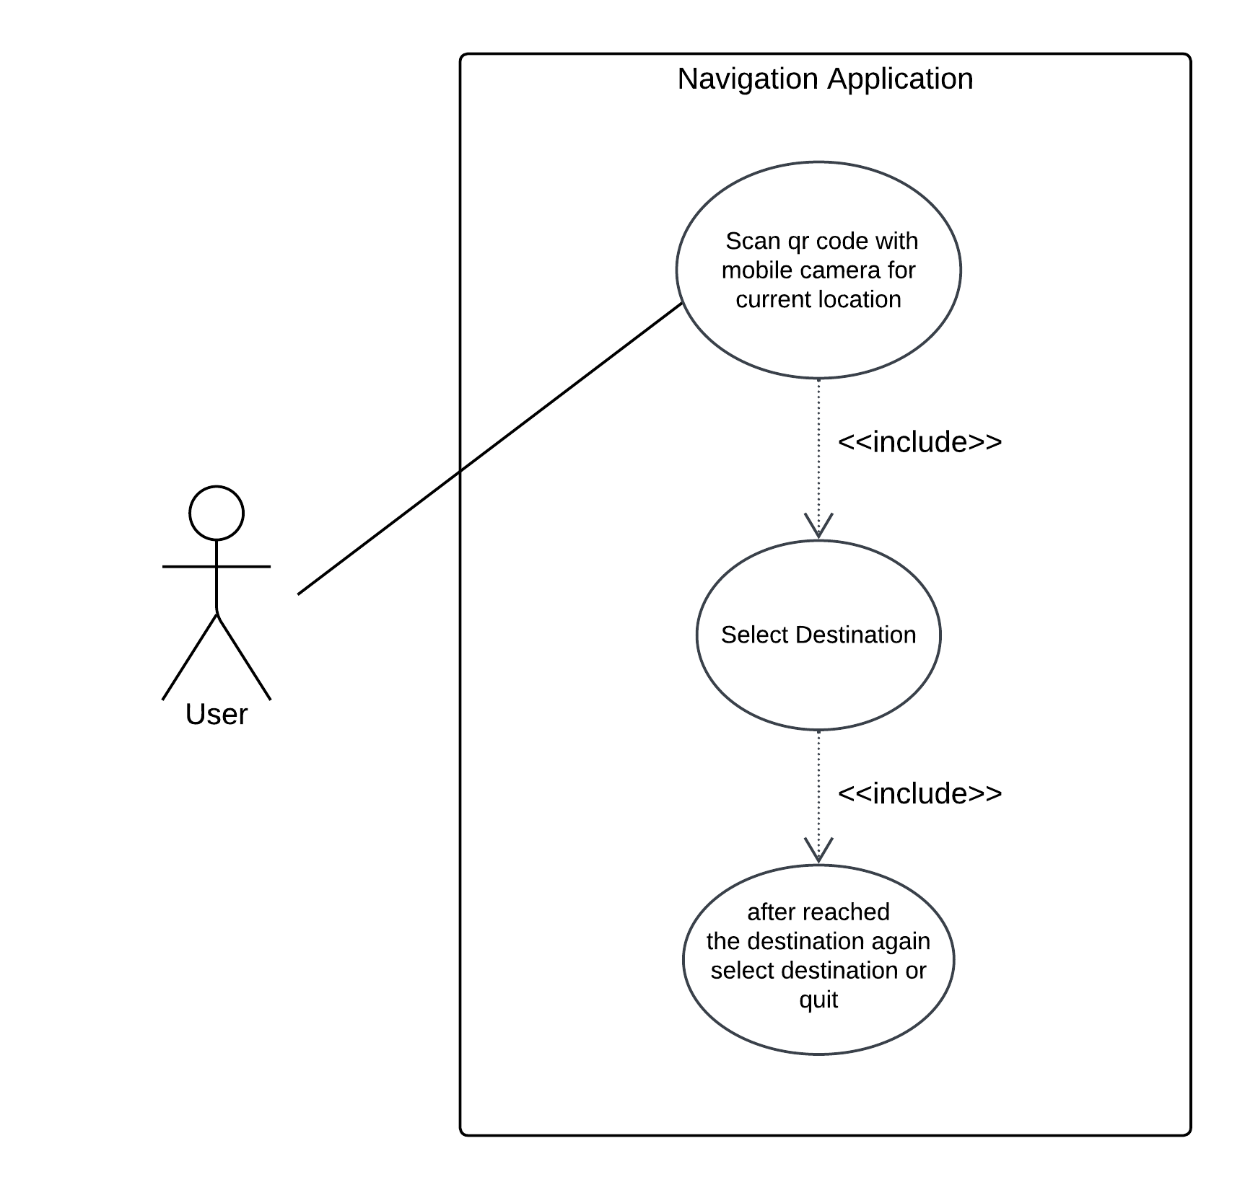In the use case scenario the user will scan QR code with mobile camera to get current location, then the user will select destination, after reaching the destination the user will get option to quit or select another location. The Use Case of application is shown in ***Figure 3.1***

Figure 3.: Use-Case Diagram of AR-Based Indoor Navigation App

## Activity Diagram

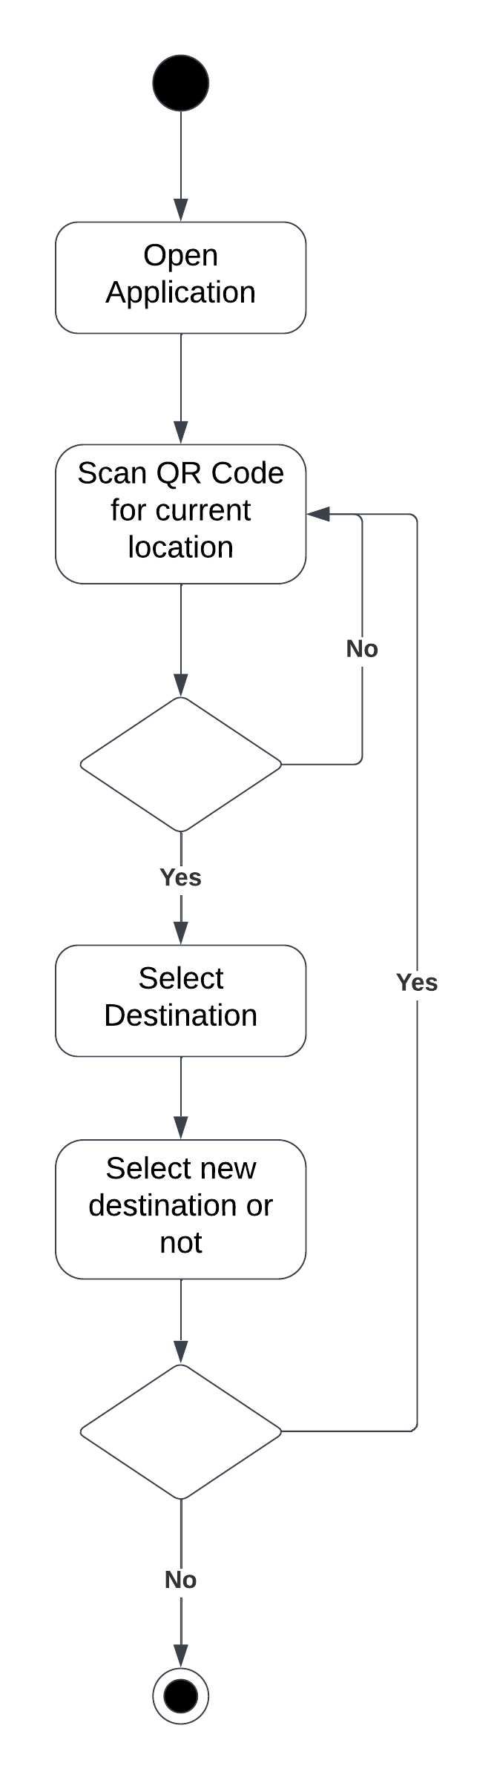The activities that user will perform in our application are: Open application, scan QR code to get current position, select destination, follow the path, after reaching destination the user will select an option to quit or go to another location. The activity diagram is shown in ***Figure 3.2***

Figure 3.: Activity Diagram of AR-Based Indoor Navigation App

## Domain Model Diagram

In domain model diagram, functions of the software are not described, otherwise it is similar to the class diagram. There are two classes in our application **MapAndQrCode** and **Navigation**, The **MapAndQrCode** class stores the map of our application as well as QR code while the **Navigation** class stores the variables for navigation through augmented reality. The lines are indicating that these classes can interact with one another at least one time or maximum multiple times as well which are shown in the ***Figure 3.3***

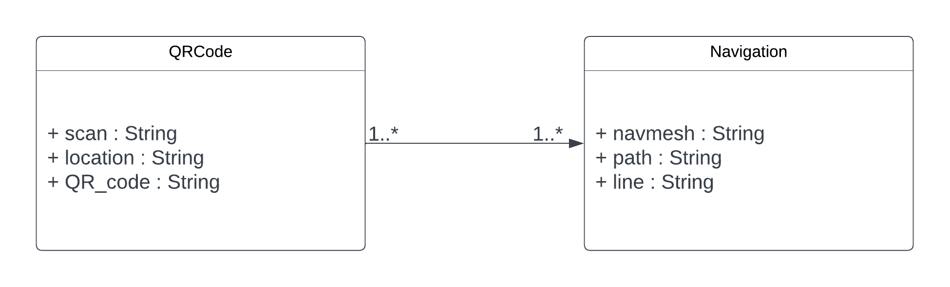

Figure 3.: Domain Model Diagram of AR-Based Indoor Navigation App

## System Sequence Diagram

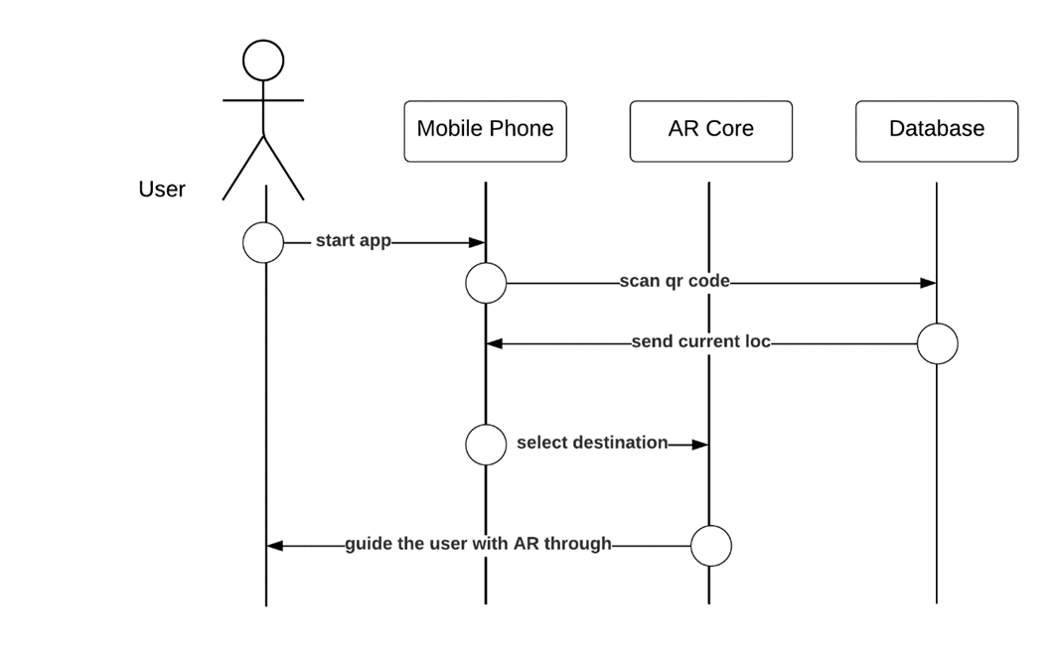The System Sequence Diagram shows the sequence of events occurring in a system and also shows the high level overview of interactions between objects and components. In our case, The user starts the application, scans the QR code, a request is sent to database, the database respond the user request by sending current location after this the user select destination, again a request is sent to AR Core feature that respond the user request by guiding the user with Augmented Reality. The above explanation is shown as System Sequence Diagram in ***Figure 3.4***

Figure 3.: System Sequence Diagram of AR-Based Indoor Navigation App

## Sequence Diagrams

A Sequence Diagram is similar to System Sequence Diagram as it also shows the interaction between components and objects but on a small level. It shows the interaction between objects and components of a single process while System Sequence shows the interaction of multiple processes. Moreover, the Sequence Diagram describes the objects and their lifeline as well.

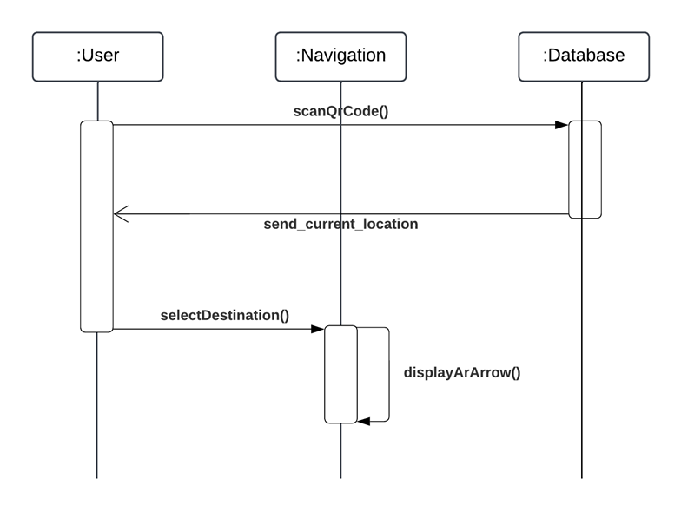The Sequence Diagram of our application is showing three objects and their lifeline as well, the **User object** is activate on **scanQrCode()** method sent to **Database object** and ends on **selectDestination()** method sent to **Navigation object** and after that the it dies, the other objects are also gone through the same process as shown in ***Figure 3.5***

Figure 3.: Sequence Diagram of AR-Based Indoor Navigation App

## Class Diagram

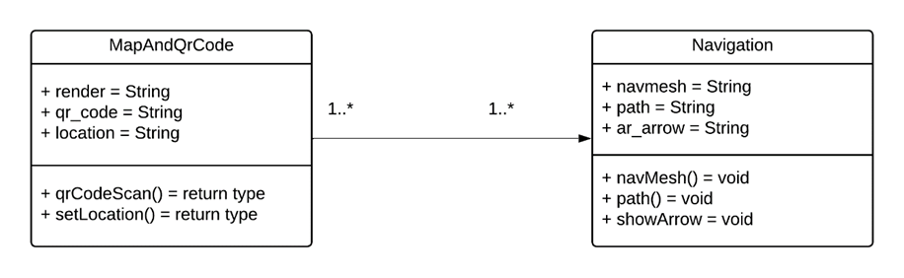In Class diagram, functions of the software are also described, unlike to Domain Model. There are two classes in our application **MapAndQrCode** and **Navigation**, The **MapAndQrCode** class stores the variables and function used for map of our application as well as for QR code while the **Navigation** class stores the variables and functions for navigation to guide the user through augmented reality. The lines are indicating that these classes can interact with one another at least one time or maximum multiple times as well which are shown in the ***Figure 3.6***

Figure 3.: Class Diagram of AR-Based Indoor Navigation App

## Architecture Diagram

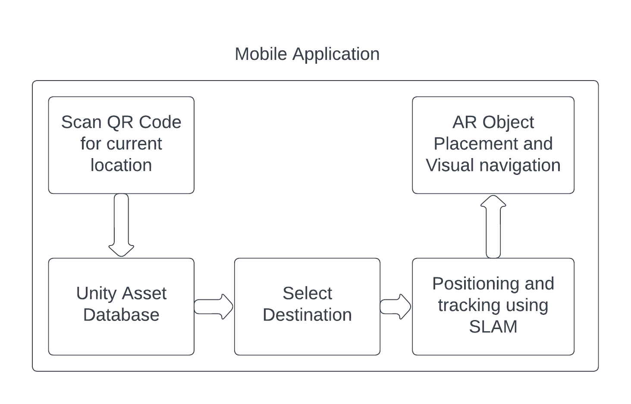An Architecture Diagram represents interaction between components and system and also represents modules, interfaces, data flow, and dependencies etc. that makes up to the software. The modules of the application are shown in the ***Figure 3.7***

Figure 3.: Architecture Diagram of AR-Based Indoor Navigation App

## Work breakdown structure (WBS)

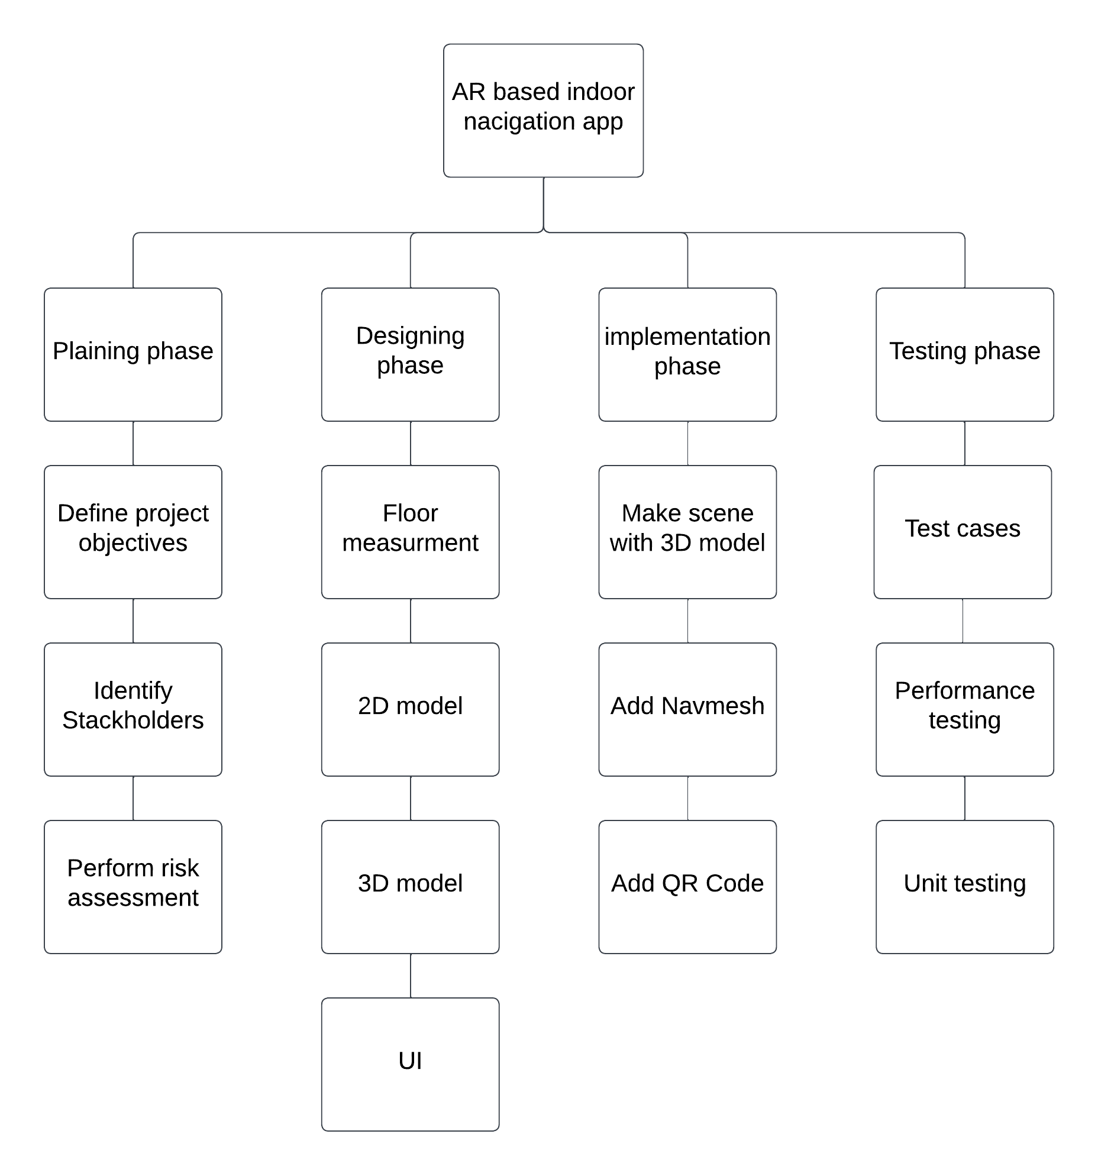Work Breakdown Structure (WBS) refers to a hierarchical decomposition of the project deliverables and work activities required to complete a project. It breaks down the project scope into smaller, manageable components which makes it easier to plan, organize, and track the progress as shown in ***Figure 3.8***

Figure 3.: WBS of AR-Based Indoor Navigation App

## Collaboration Diagram

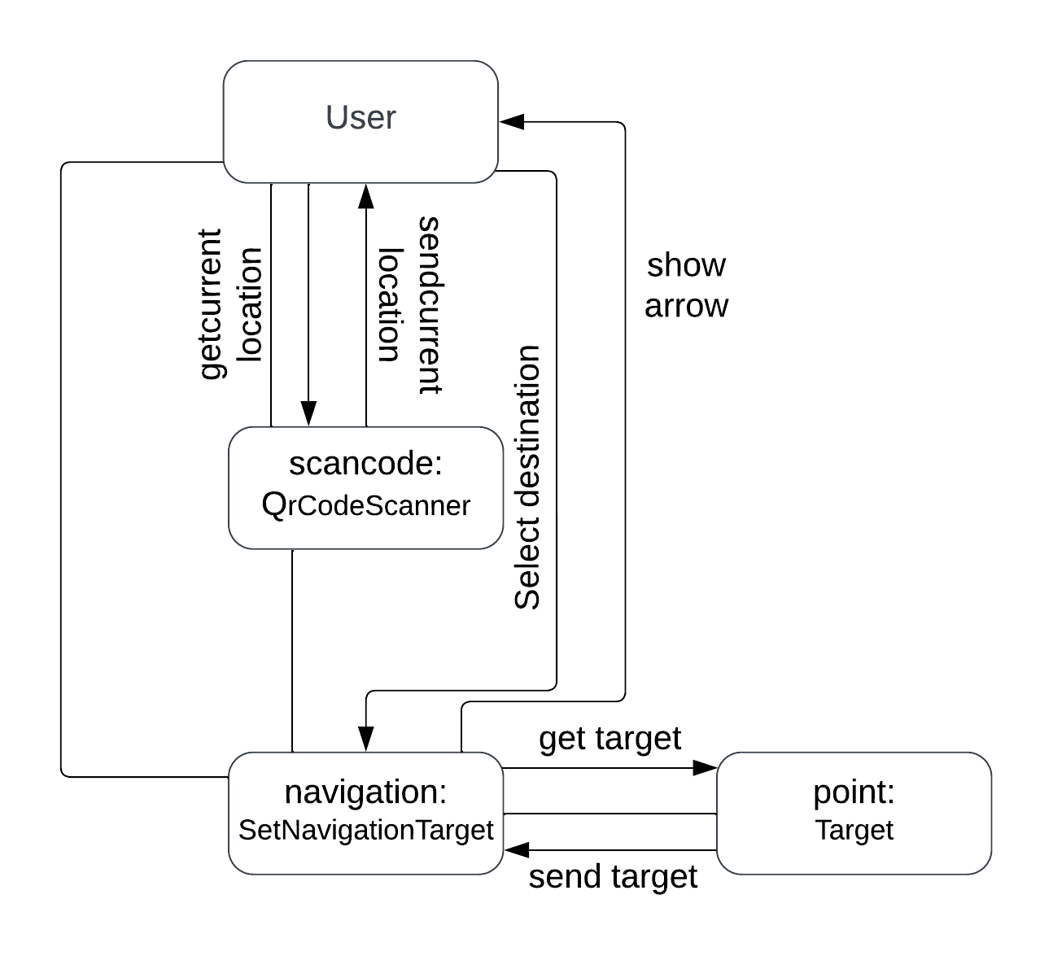A collaboration diagram provides a visual representation of how objects or components in a system interact and collaborate with each other to achieve a specific functionality or behaviour as shown in ***Figure 3.9***

Figure 3.: Collaboration Diagram of Indoor Navigation App

## Gantt chart

A Gantt chart provides visual representation of project tasks, their durations, and their dependencies over a specific timeframe. It provides a timeline view of the project, allowing project managers to schedule and track activities efficiently as shown in ***Figure 3.10***

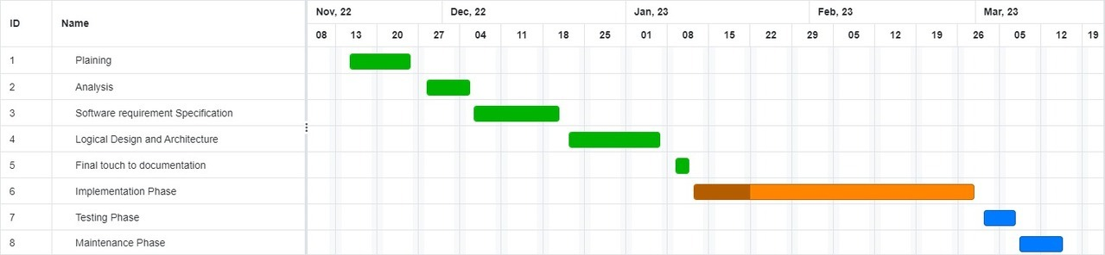

Figure 3.: Gantt chart of AR-Based Indoor Navigation App

# System Testing

System testing is the process which involves creating and executing test cases for verifying and validating the functionality and performance of the system based on the documented requirements.

## Test Cases

Test cases are specific scenarios or conditions that are designed to check if the system meets the specified requirements, functions as intended, and satisfies the project objectives as mentioned in the documentation.

Table .: Test Case 1 (Pass) of AR-Based Indoor Navigation App

|  |  |
| --- | --- |
| **Test ID:** | ARNav_001 |
| **Test case Name:** | QR Code Scanning |
| **Test case type:** | Functionality |
| **Description:** | Test the functionality of scanning a QR code to find current location |
| **Expected Result:** | If we scan a QR code, it provides us with the current location. |
| **Status:** | Pass |
| **Actual Result** | It gives us an accurate current location |

Table .: Test Case 1 (Fail) of AR-Based Indoor Navigation App

|  |  |
| --- | --- |
| **Test ID:** | ARNav_002 |
| **Test case Name:** | QR Code Scanning |
| **Test case type:** | Functionality |
| **Description:** | Test the functionality of scanning a QR code to find current location |
| **Expected Result:** | If scan is not successful then a pop-up message will show that “scan is not successful” |
| **Status:** | Fail |
| **Actual Result** | It shows a pop-up message that scan not successful |

|  |  |
| --- | --- |
| **Test ID:** | ARNav_003 |
| **Test case Name:** | Select Destination |
| **Test case type:** | Functionality |
| **Description:** | A list of destinations is displayed, and you can select one of them. |
| **Expected Result:** | The user's selection is acknowledged by the system. |
| **Status:** | Pass |
| **Actual Result:** | When the user select destination arrows show, according to selected destination |

Table .: Test Case 2 (Pass) of AR-Based Indoor Navigation App

|  |  |
| --- | --- |
| **Test ID:** | ARNav_004 |
| **Test case Name:** | Select Destination |
| **Test case type:** | Functionality |
| **Description:** | A list of destinations is displayed, and you can select one of them. |
| **Expected Result:** | If user has already selected the destination and meanwhile select again, then a pop-up message will show that “Please clear navigation first” |
| **Status:** | Fail |
| **Actual Result:** | The user sees a pop-up message that “Please clear navigation first” |

Table .: Test Case 2 (Fail) of AR-Based Indoor Navigation App

|  |  |
| --- | --- |
| **Test ID:** | ARNav_005 |
| **Test case Name:** | Navigation |
| **Test case type:** | Functionality |
| **Description:** | Test the navigation functionality using the generated NavMesh. |
| **Expected Result:** | Show 3d arrows, from starting point to select destination. |
| **Status:** | Pass |
| **Actual Result:** | The user sees 3d arrows |

Table .: Test Case 3 (Pass) of AR-Based Indoor Navigation App

|  |  |
| --- | --- |
| **Test ID:** | ARNav_006 |
| **Test case Name:** | Navigation |
| **Test case type:** | Functionality |
| **Description:** | Test the navigation functionality using the generated NavMesh. |
| **Expected Result:** | If the user moves slightly off the defined path, then inaccurate direction towards the desired destination is shown. |
| **Status:** | Fail |
| **Actual Result** | The user sees 3d arrows in the wrong direction |

Table .: Test Case 3 (Fail) of AR-Based Indoor Navigation App

# Conclusion

## Problem faced and lessons learned

**Problem faced:** We encountered challenges related to a static environment and lighting conditions, which affected the accuracy of QR code scanning. Additionally, the limitation of navigation to entrance points created inconvenience for users if there was no nearby entrance.

**Lessons learned:** Based on these challenges, we have learned the importance of adapting to dynamic environments and exploring alternative location scanning methods. Seamless destination selection from the current location should be enabled to eliminate the need to return to an entrance for scanning QR codes. Implementing error handling and redirection mechanisms is crucial for correcting navigation errors and keeping users on the correct path.

## Project summary

Our project focuses on developing an AR-based Indoor Navigation Application that addresses the challenge of indoor navigation and overcomes the limitations of traditional navigation tools and GPS systems. We utilized the SLAM algorithm and QR code technology for real-time positioning and mapping, eliminating the need for external hardware. The application overlays digital objects in the user's real-world view and calculates optimized routes using the NavMesh tool in Unity. Through our project, we aimed to enhance indoor navigation, provide a user-friendly platform, save time and energy, and enhance user experience within indoor environments.

## Future work

The future work includes addressing the limitations encountered and exploring new possibilities.

This includes:

* Extending the scope of application to multiple floors.
* Adding redirection capabilities to handle incorrect path taken by the user.
* Expanding to IOS devices to reach a wide range of users.
* Adding a voice assistant feature to enhance accessibility for visually impaired users.
* Enabling seamless destination selection, allowing users to choose new destinations directly from their current location without needing to go back to an entrance to scan the QR code.

# References

1. Kushal Agrawal, S.V.P.V. (2020) ‘Indoor Navigation using Augmented Reality’, *EAI Endorsed Transactions on Creative Technologies*, 8(26), p. 168718. Available at: https://doi.org/10.4108/eai.17-2-2021.168718.
2. Bacchewar, Y. *et al.* (2022) *EasyChair Preprint Indoor Navigation Using Augmented Reality*.
3. Joshi, R. *et al.* (2020) ‘Indoor Navigation with Augmented Reality’, *Lecture Notes in Electrical Engineering*, 570, pp. 159–165. Available at: https://doi.org/10.1007/978-981-13-8715-9_20.
4. Sukhareva, E., Tomchinskaya, T. and Serov, I. (2021) ‘SLAM-based Indoor Navigation in University Buildings’, 6116, pp. 0–3.

# Appendix A: User Interface

1. **Scan QR Code**

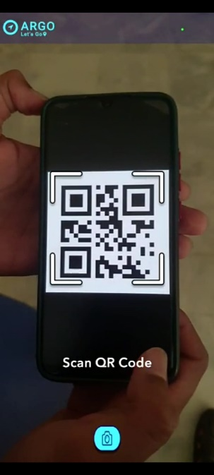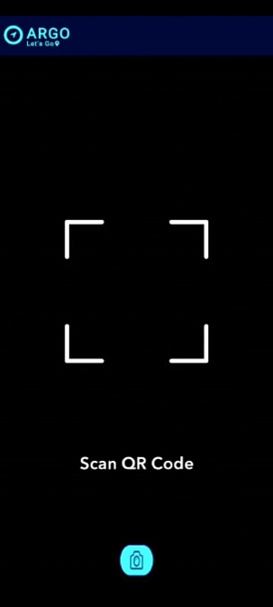When user open the application this interface will appear as shown in ***Figure A.1***, the user will scan QR Code to get current location.

Figure A.: User Interface of Scan QR Code

1. **Select Destination**

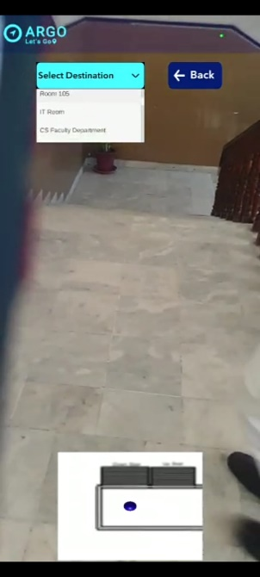After the successful scanning of QR Code, this interface will appear ***Figure A.2.***

Figure A.: User Interface of Select Destination

1. **Navigation through Augmented-Reality Arrows:**

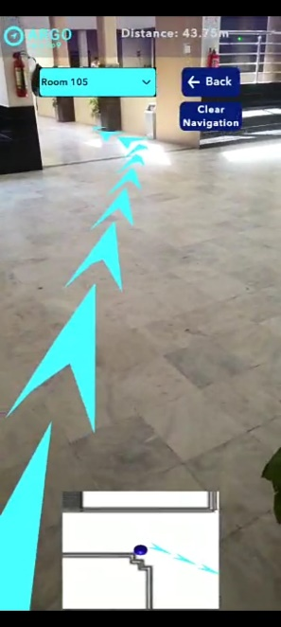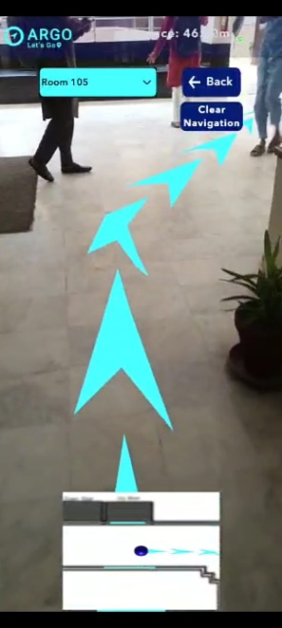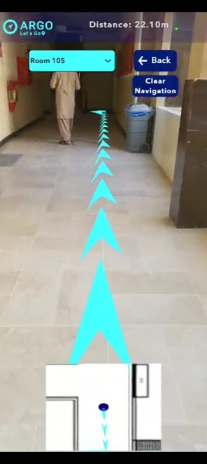After selecting the desired destination, the user will be guided through Augmented Reality Arrows to the desired destination as shown in ***Figure A.3.***

Figure A. : User Interface of Augmented-Reality Arrows showing path

1. **Reach Destination**

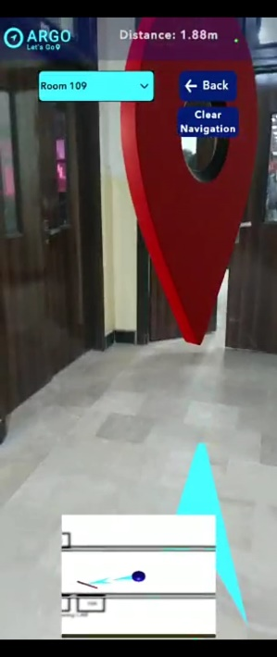When the user reach the desired destination, this interface will appear as shown in ***Figure A.4.***

Figure A.: User Interface of Reaching Destination

# Appendix B: Plagiarism Report

